User Manual

Treasure Box Braille: Authoring App

Group 19: Connor Ahearn, Micah Arndt, and Kevin Chan

Table of Contents

1. **Document Overview**

**1.1** System Requirements **3**

**1.2** Installation  **3**

1. **Scenario Creator 3**
   1. Getting Started **4**
   2. Scenario Setup **5**
   3. Scenario Creator GUI **6**
      1. Section Name **7**
      2. Answer Buttons Used **7**
      3. Story **8**
      4. Braille **8**
      5. Answer **8**
      6. Add Sound **9**
      7. Correct **9**
      8. Incorrect **9**
      9. Save Section **10**
      10. Clear Section **10**
      11. Drop down Menu **10**
      12. Scenario Menu **11**
      13. Menu Items
          1. Scenario Menu Items **12**
          2. Section Menu Items **12**
          3. Go To Menu Items **13**
          4. Sound Menu Items **13**
   4. Save Scenario **13**
   5. Load Scenario **14**
   6. Test Scenario **14**
   7. Set Pins on Braille Cell(s) **15**
   8. Add Sound **15**
      1. Record Audio **16**
      2. Import Audio **16**
   9. GUI Audio Accessibility **16**
   10. Logger **17**
2. **Hot Keys 17**
   1. Functional **17**
   2. Navigational **17**

**1.0 Document Overview**

This document aims to provide an overview of the functions and accessibility features of the Scenario Creator software. It contains detailed instructions on how to use the program as well as a list of short cuts available.

**1.1 System Requirements**

The Scenario Creator software is compatible with Windows, Linux and Mac Operating Systems. The audio accessibility features are compatible with the following screen readers:

NVDA (Windows), ORCA (Linux), and Voiceover (Mac)

**1.2 Installation**

To install the Scenario Creator, simply download the AuthoringApp.lib.zip file from GitHub. Once the download is complete, open the file and double click on the AuthoringApp.jar file to start creating!

**2.0 Scenario Creator**

This section of the document takes a closer look at the functions and accessibility features of the Scenario Creator. The software helps you manage your scenario more easily by breaking it down into sections.

Each section will contain a story element, where you can provide a small lesson [ex. demonstrate what a word looks like in braille] or you can ask a question and receive button press answers (ex. you can have a word displayed on the braille cells and provide multiple choice answers associated with the buttons on the Treasure Braille Box. You can also choose what happens when a correct or incorrect response entered and create as many sections as you want for your scenario. At the end of every section, the braille cell pins are automatically reset to display nothing.

You can also record or import sound files to use in your scenario and the software features full audio accessibility so that the Scenario Creator app can be used by the visually impaired.

**2.1 Getting Started**

Once you have double clicked on the AuthoringApp.jar file, you will be taken to the starting window.

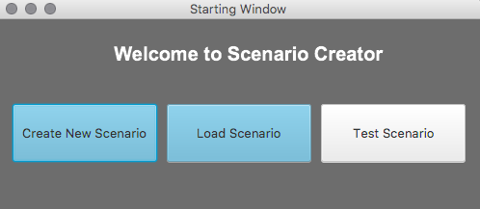

**Create New Scenario**

This will take you to the Scenario Setup window.

**Load Scenario**

This will open up a file chooser so that you can load a previously saved scenario. See section 2.5 for more details on loading.

**Test Scenario**

This will open up a file chooser to that you can test a previously saved scenario. The test is run using provided software that simulates the Treasure Braille Box. See section 2.6 for more details on testing.

**2.2 Scenario Setup**

After selecting Create New Scenario, you will be brought to the Scenario Setup window.

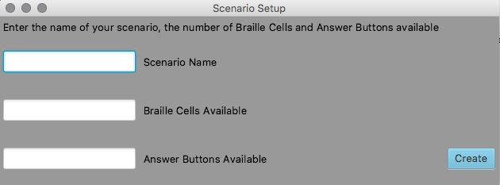

**Scenario Name:**

Enter the title of your scenario in this text field. Later on when you choose to save your scenario, a .txt named after the title will be created and saved on your system.

*• This field cannot contain less than 15 characters. A warning window will display if you leave this field empty and try to click on the Create button.*

**Braille Cells Available:**

Enter the number of Treasure Box Braille cells you have available.

*• This field must contain a number. A warning window will display if you leave this field empty or enter a non-numeric character and on click the Create button.*

**Answer Buttons Available:**

Enter the number of answer buttons available on the braille cells.

*• This field must contain a number. An warning window will display if you leave this field empty or enter a non-numeric character and on click the Create button.*

**Create:**

Once the fields have been completely, click or press enter on this button to start creating!

**2.3 Scenario Creator GUI**

After clicking create, you will be brought to the main Scenario Creator Window. This section details the different parts of the Scenario Creator graphic user interface (GUI) and provides an overview of what each element is for and what to write in each text field.

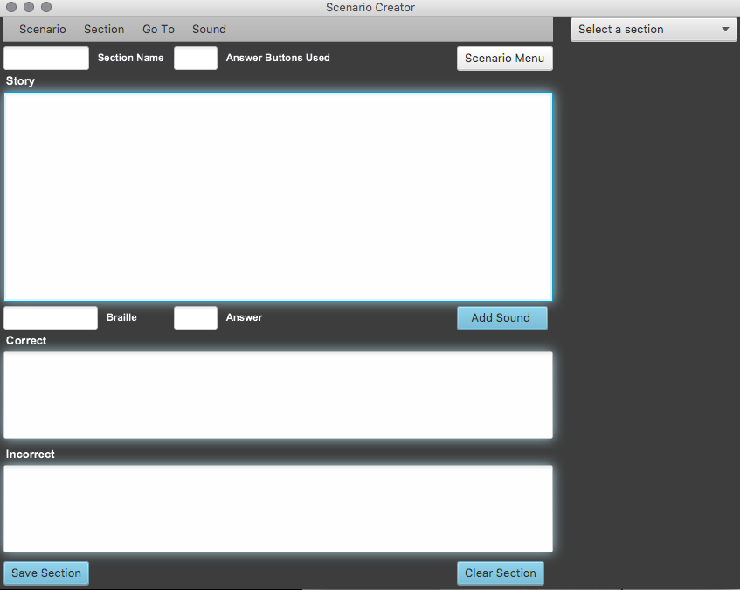

**2.3.1 Section Name**

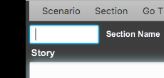

Enter the name you want for the section. After the section has been saved, the name you used here will appear in the drop down menu, so that you can come back and edit this section anytime.

*• This field cannot be empty. A warning window will display if you leave this field blank and try to save the section.*

**2.3.2 Answer Buttons Used**

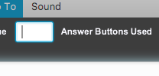

Enter the number of answer buttons you want active during this section. At least one button has to be used. If you are simply doing a demonstration of what a letter looks like in braille, you could just simply set 1 button to be used. All the other buttons will be left inactive, and the student can click on the chosen button to skip to the next section.

*• This field must contain a number that is less than or equal to the number of answer buttons available, as indicated in the Scenario Setup window. A warning window will display if you leave this field blank or enter a non-numeric character and try to save the section.*

**2.3.3 Story**

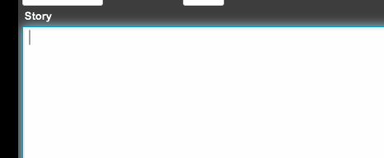

This is the text field in which you can write your short lesson or ask you question. If you are asking multiple choice questions, you should let students know what the choices are associated with here. You can also add sounds in this text field, see section 2.9 for more details on adding sound.

*• This field must at least 15 characters. A warning window will display if you have less than 15 characters entered for your story and try to save the section.*

**2.3.4 Braille**

**Screen%20Shot%202018-08-20%20at%2011.07.52%20PM.png**

Enter the letter or word you want displayed on the braille cell here.

*• This field must contain a letter or a word that is less than or equal to the number of braille cells that you have available, as indicated in the Scenario Setup window. A warning window will display if you leave this field blank or enter a non-numeric character and try to save the section*

**2.3.5 Answer**

**Screen%20Shot%202018-08-20%20at%2011.17.01%20PM.png**

Enter the button number that you want associated with the correct response.

*• This field must contain number that is less than the number of answer buttons available. A warning window will display if the conditions are not met and you try to save the section.*

**2.3.6 Add Sound**

**Screen%20Shot%202018-08-20%20at%2011.19.58%20PM.png**

This button will take you to the Sound Menu where you can record or import sounds. See section 2.9 for more details on adding sound.

**2.3.7 Correct**

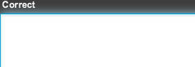

You can enter the message you want played when a student has triggered the correct response. You can also add sound to this text field. See section 2.9 for more details on adding sound.

**2.3.8 Incorrect**

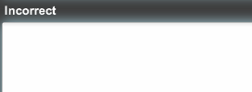

You can enter the message you want played when a student has triggered the wrong response. You can also add sound to this text field. See section 2.9 for more details on adding sound.

**2.3.9 Save Section**

**Screen%20Shot%202018-08-20%20at%2011.29.19%20PM.png**

After the required fields [Section Name, Answer Buttons Available, Story, Braille and Answer] are filled out properly, pressing this button will save this section, and the section name will appear in the drop down menu so that you can return to it at another time.

*•* ***IMPORTANT:*** *closing the Scenario Creator app at this point will delete all progress. In order to save the sections onto your computer, you must choose to save the scenario. See section 2.4 for more information about saving scenarios.*

**2.3.10 Clear Section**

**Screen%20Shot%202018-08-20%20at%2011.43.34%20PM.png**

Pressing this button will clear every field in the Scenario Creator, a warning dialog will appear first as doing so will lose any unsaved progress.

**2.3.11 Drop down Menu**

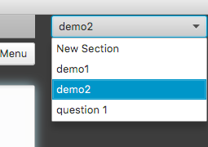

This drop down menu provides a quick way for you to navigate back and forth between different sections. Simply select the section you want to go to and the Scenario Creator will automatically repopulate the text fields with the saved information.

**2.3.12 Scenario Menu**

**/Users/kevinchan/Desktop/Screen Shot 2018-08-21 at 12.28.21 AM.png**

This quick access scenario menu button opens up a separate window which provides you with access to the main functions associated with the scenario.

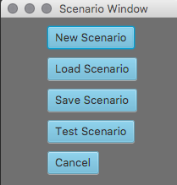

**New Scenario**

This will take you to the Scenario Setup window, all unsaved progress will be lost.

**Load Scenario**

This will open up a file chooser so that you can load a previously saved scenario. See section 2.5 for more details on loading.

**Save Scenario**

As long as one section is saved, pressing this button will save a .txt named after the title of your scenario onto your system. The .txt file will be formatted to work with the braille simulator program. See section 2.4 for more details on saving.

**Test Scenario**

This will open up a file chooser to that you can test a previously saved scenario. The test is run using provided software that simulates the Treasure Braille Box. See section 2.6 for more details on testing.

**Cancel**

This will return you to the main Scenario Creator Window.

**2.3.12 Menu Items**

This section will detail the functions that available from the Menu

**2.3.12.1 Scenario Menu Items**

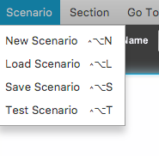

This menu bar item contains the same contents as the quick access scenario menu. The functions performed are identical to those of the Scenario Menu, but it provides a reminder of the keyboard shortcuts that exist for the four features. See section 3.0 for more information about hot keys.

**2.3.12.2 Section Menu Items**

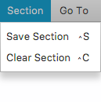

This menu bar item allows users to save or clear the section. The functions performed are identical to the save section and clear section buttons found in the main GUI, but it provides a reminder of the keyboard shortcuts that exist for the two features. See section 3.0 for more information about hot keys.

**2.3.12.3 Go To Menu Items**

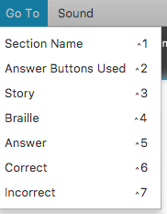

This menu item serves as a reminder of keyboard short cuts that exist which will allow users to jump to a specific item in the Scenario Creator GUI. Selecting an item from this menu will also move the focus to the specific item in the GUI.

**2.3.12.4 Sound Menu Items**

**/Users/kevinchan/Desktop/Screen Shot 2018-08-21 at 12.42.53 AM.png**

This menu item serves as a reminder of keyboard short cuts that exist which will allow users to quickly add sounds to their scenario. See section 2.9 for more details on adding sound.

**2.4 Save Scenario**

You must have saved as least one section before you can save a scenario. When a scenario is saved, a .txt named after the scenario title is saved onto your system. This is not a regular text file, as it has been formatted by the software in order to make it compatible with the braille cell simulator. As such, it is best you do not directly edit the text file, as it can potentially corrupt the entire scenario file. Use the loading / editing tool instead, that’s what it is there for.

**2.5 Load Scenario**

You can choose to load a previously saved scenario from the starting window or from within the Scenario Creator App itself. Be careful as doing so will delete any unsaved progress on the current scenario you are working on.

As stated in the previous section, the scenario text file is formatted to work with the braille cell simulator software. Therefore, only .txt files created from the Scenario Creator app can be loaded.

**2.6 Test Scenario**

You can choose to test a previously saved scenario from the starting window or from within the Scenario Creator App itself. After selecting an appropriate file, a new window named Simulator will open.

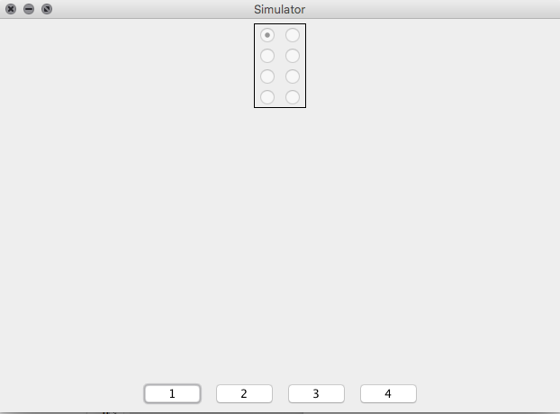

This mimics the braille cell. Turn on audio accessibility to hear spoken dialog describing changes made in the GUI, such as the pins that are displayed.

**2.7 Set Pins on Braille Cell(s)**

Setting the pin(s) you want displayed on the braille cell is as easy as typing the word or letter you want displayed in the Braille text box in the Scenario Creator GUI.

At this time, the Braille cell field can only accept alphabetical characters. Also make sure that the word you type in the Braille cell field contains fewer characters than the number of braille cells you have available.

**2.8 Add sounds**

This section details how you can add audio to your scenario. After choosing the add sound option, either via the button in the Scenario Creator GUI, or through the keyboard shortcut, you will be brought to the sound Menu.

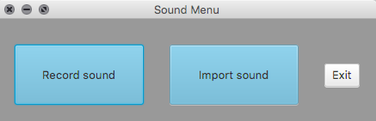

Users can add sounds to the Story, Correct or Incorrect text fields by typing /~sound: followed by the name of the sound file including the .wav file extension. /~sound: example.wav

**2.8.1 Record Audio**

After pressing the Record Sound button, you will be prompted to name the sound file. A .wav file with the name you provided will be saved on your system. After clicking okay, you will be brought to the Record window.

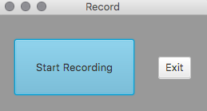

**Start Recording**

Pressing this button will start the recording. The maximum record time is one minute and you can press the button to stop recording. You can record as many sound files as you like.

**Exit**

Pressing this button will return you to the main Scenario Creator window.

**2.8.2 Import Audio**

Choosing the import audio option will open up a file chooser so that you can load a .wav file into program. Typing /~sound: eample.wav will add the sound file into your scenario.

**2.9 GUI Audio Accessibility**

Both the scenario creator and the braille cell simulator has audio accessibility. The audio accessibility features are compatible with the following screen readers: NVDA (Windows), ORCA (Linux), and Voiceover (Mac).

With screen readers enabled on your system, the software will read out what each element of the GUI is for, and how to use it. Verbal descriptions of changes that occur on screen are also provided, for example when a scenario is saved, or when the simulated braille cell changes positions.

**2.10 Logger**

A .txt file entitled the log of doom, will be saved onto the user’s system. This will keep track of functions and features accessed, as well as any errors that occur during the running of the software.

**3.0 Hot keys**

This section provides a list of the hot keys available in this software.

**3.1 Functional**

These hot keys are associated with the features and functions of the Scenario Creator.

|  |  |
| --- | --- |
| **Command** | **Hot Key** |
| New Project | Alt + Control + N |
| Load Project | Alt + Control + L |
| Save Project | Alt + Control + S |
| Test Project | Alt + Control + T |
|  |  |
| Save Section | Control + S |
| Clear Section | Control + C |
|  |  |
| Add Sound Menu | Control + Shift + S |

**3.2 Navigational**

These hot keys are associated with making it easier to navigate through the Scenario Creator GUI.

|  |  |
| --- | --- |
| **Command** | **Hot Key** |
| Focus on Section Name Text Field | Control + 1 |
| Focus on Answer Buttons Used Text Field | Control + 2 |
| Focus on Story Text Field | Control + 3 |
| Focus on Braille Text Field | Control + 4 |
| Focus on Answer Text Field | Control + 5 |
| Focus on Correct Text Field | Control + 6 |
| Focus on Incorrect Text Field | Control + 7 |
|  |  |
| Jump to next element in GUI | Hold Control + tab |
| Jump to Menu Bar | Option |